**3.3 STORYBOARD AND DESIGN**

**3.3.1 System Flow Chartb**

Monthly Statistic

Weekly Statistic

Date Chooser

Daily Statistic

Daily Prayer

Good Deed

My Statistic

My Activity

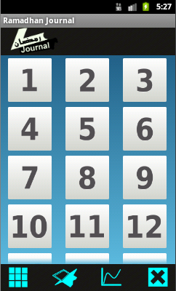**3.3.2 Interface Design**

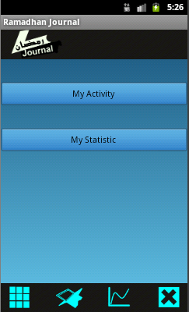

Start

My Activity

My Statistic

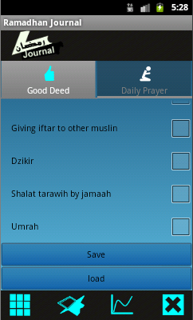

Good Deed

End

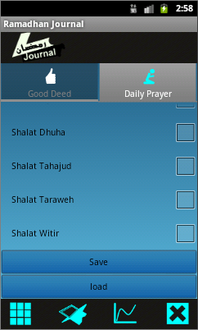

Daily Prayer

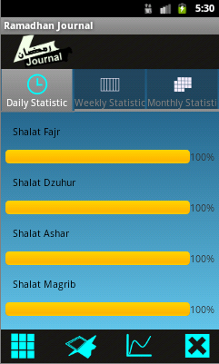

Daily Statistic

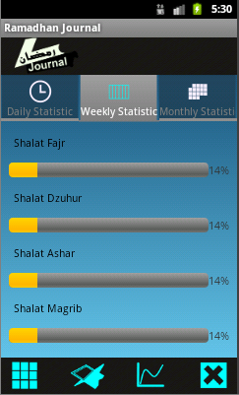

Weekly Statistic

End

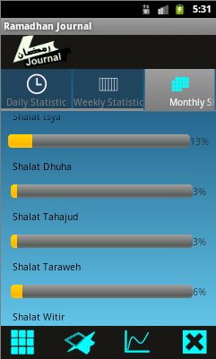

Monthly Statistic

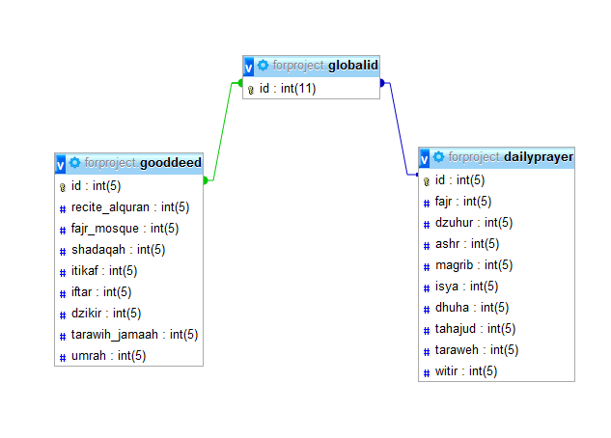**3.3.3 Database Design**